Poly Shrink Flowers and Leaves

Tools needed:

1x Poly shrink translucent scalloped edge circle punch

flower shape punch small paper hole-punch

Fine grit sandpaper tiny glass beads headpins jump rings

pliers

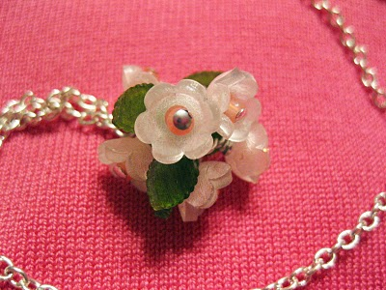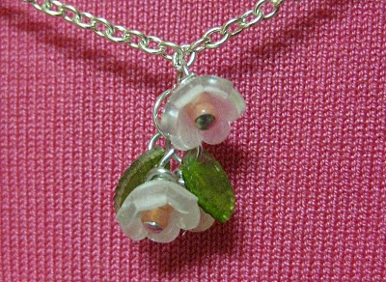

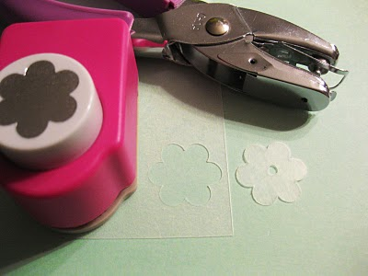
Before using your Poly Shrink, read sanding instructions on packet.
Once sanded use the flower shape punch, punched out several flowers. Then with a small paper hole-punch, center punched each.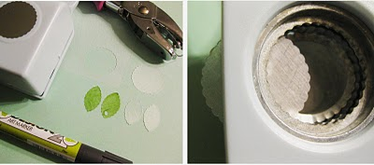
For the leaves, used a scalloped edge circle punch and made several circles that again ran back through the punch in halves to create 2 separate leaves per circle, colour them with a marker and punch small holes in the end of each.
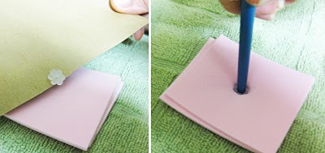
Following the Poly Shrink heating directions, bake each flower individually to shrink, scraped them onto a stack of cut craft foam sheets and immediately, while the flower is warm, squished with the end of a paintbrush to create a bowl effect.
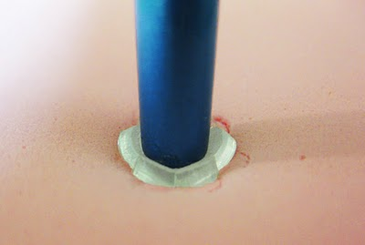
I then baked all my leaves at once.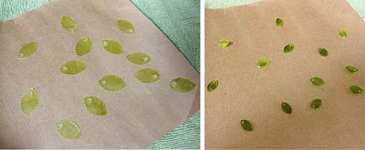
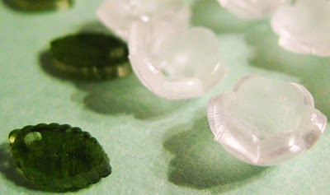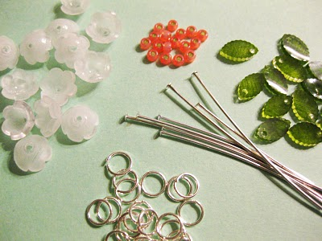
With tiny glass beads, headpins, jump rings and pliers, I created the finished flowers
.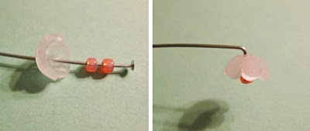
Threading two beads through worked best for the centre to stick out a bit from the bowl of the flower. I then stacked the flower and created a bend in the wire.
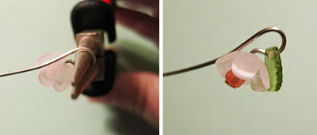
Wrapping the wire around round-nose pliers, left an opening to thread on one leaf.
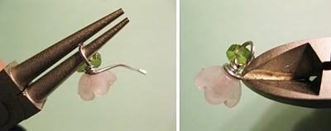
Finish with a few twists and a snip of the wire cutters.
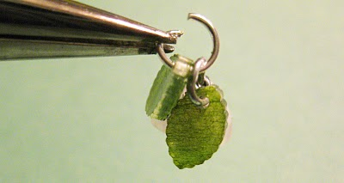
Finally, clustering flowers and leaves with jump rings I made a few different small bouquets pendants.

VARIATIONS: Try different flower shapes and colouring techniques. Coloured pencils create a very dark and rich result when baked, whereas markers are a bit more subtle. Use a fine-point Sharpie pen to write your children’s’ names or motivational words on the leaves

